/`

NAME
SUBJECT | TECHNICAL DRAWING 1 & 2 | CLASS | SS2 | DURATION | 2 ½ HOURS

INSTRUCTIONS: This booklet consists of two papers. Answer paper 1 in your Objective Test answer sheet and paper 2 in your answer booklet. Paper 1 will last for 1 hour after which the answer booklet will be collected. Do not start paper 2 until you are told to do so. Paper 2 will last for 1 ½ hours.

PAPER 1 (1 hour)
OBJECTIVES (40 MARKS

- Which of the blocks below is drawn obliquely?….
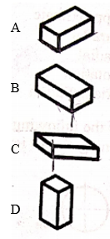
- The auxiliary view object can be used to determine the following EXCEPT
- Edge-view of a plane
- Point-view of a line
- True size and form of a plane
- Vanishing point
Use the drawing below to answer questions 3 and 4.
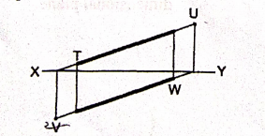
- Which of the following is horizontal trace?
- T
- W
- U
- V
- Which of the following is vertical trace?……
- T
- U
- V
- W
- The type of arc drawn below is

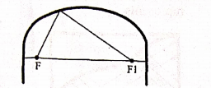
- Elliptical
- Lancet
- Segment
- Semicircular
Use the drawing below to answer questions 31 and 32.
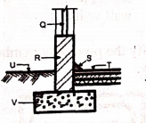
- Window is represented by letter
- Q.
- R
- T
- S
- The part labelled V is
- Concrete slab
- lintel
- foundation footing
- wall
- The material symbol shown below is
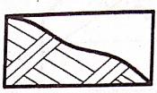
- concrete
- rock
- sand
- glass
- Which of the following is shown on the blueprint?
- Contract fee
- Contract firm
- Cost of materialsl
- Location of project
- The part of the roof labelled K in the figure below is called.
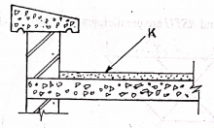
- Bituminous felt
- concrete roof
- sandcrete screed
- parapet wall
- The function of internal wall is to
- Carry weight
- Divide space
- Enhance stability
- Reinforced foundation
The figure below is the frame of a door, use it to answer questions 12 and 13
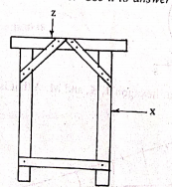
- The part labelled Z is the
- brace
- jamb
- head
- horn
- The part labelled X is
- Brace
- Jamb
- Sill
- horn
- A function of lintel is .
- Improve the appernce of openings
- Bridge opennings
- Reduce wall thickness
- Increase wall length
The figure below shows profile of a stair, use it to answer questions 15 and 16
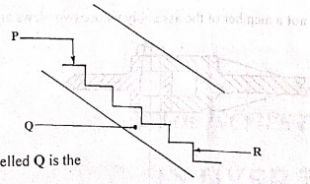
- The part labeled Q in the figure above is
- tread
- string
- riser
- landing
- The part labeled K in figure above is.
- tread
- landing
- nosing
- riser
use the diagram below to answer questions 17 and 18
A
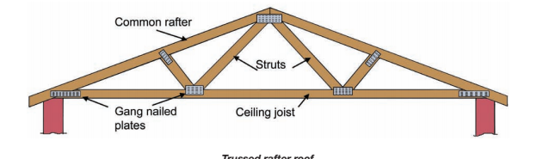
B
- The part labelled A is called.
- purlin
- strut
- ceiling joist
- hangeer
- The type of roof shown below is
- Double roof
- Lean to roof
- Close couple roof
- trussed roof
- The following are types of perspective drawing EXCEPT.
- one point perspective drawing
- two point perspective drawing
- three points perspective drawing
- four points perspective drawing
- The type of door shows below with its symbol is
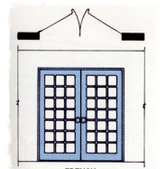
- Panel door, single swing
- French door, double swing
- Roller shutter door
- English door, single swing
- The working drawing should possess the following features except that
- types and cost of materials to be used are indicated
- title block should be properly placed.
- all views should be fully dimensioned
- all views should be clearly drawn.
- A horizontal column over a space is.
- column
- beam
- pillar
- brace
- The type of stair suitable for where space is limited is
- spiral
- straight flight
- bifurcated
- dog legged
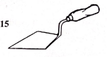
- The tool shows in the figure below is

- shovel
- angle iron
- trowel
- spade
- Which of the following features is not shown on building drawing?
- Hardcore
- Concrete
- Foundation wall
- Earth filling
- The figure below shows a part of a section through a roof and wall. The part labeled S is.
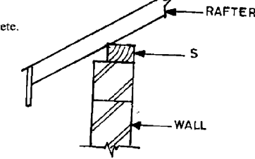
- facial board
- reinforcement
- wall plate
- lintel
Use the diagram below to answer questions 32 and 33
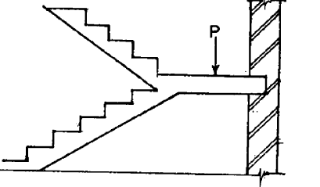
- The part labeled P is ………
- going
- landing
- flight
- thread
- How many flights are in the staircase?
- One
- Two
- Three
- Four
- Which of the following is not a type of door?
- Battern
- Raft
- Brazen
- Ledged
- A site plan shows
- Elevation of the building
- Location of the building
- Foundation of the building
- Cross section of the building
- What type of foundation is sown in the figure below?
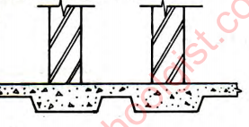
- strip foundation
- raft foundation
- piled foundation
- pad foundation
- The following are types of floor EXCEPT.
- cotton floor
- tiled floor
- suspended floor
- cement screed
- Which of the following is pitched at one side only?
- Hipped roof
- Shed roof
- Butterfly roof
- Gabble roof
- The primary function of the external walls of a building is to.
- carry load
- divide space
- reinforced building
- reinforced foundation
- Which of the building parts listed below is found on a window.
- jamb
- eave
- pile
- tread
- Which of the following is not a type of roof?
- Eaves
- Hipped
- Lean-to
- Butterfly
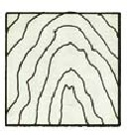
- The symbol shown below represent ……..

- wall
- ground
- wood
- tiles
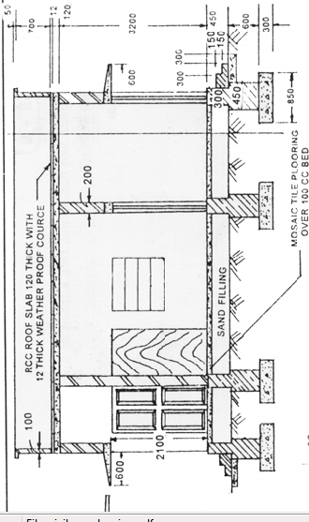
- The drawing shows below is a ……

- floor plan
- building section
- mechanical section
- structural details drawing

- Which of the symbol below represent a switch?
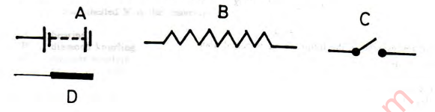
- In which of the floor construction is wall plate used?
- Solid concrete floor
- Reinforced floor
- Hollow timber floor
- Pre cast floor

PAPER 2 1 ½ hours
(60 marks)
Answer only ONE question from this paper
All dimension are in millimeters EXCEPT otherwise stated.

- The sketch below shows the plan of a bungalow. Study the give specifications and answer the question that follows:
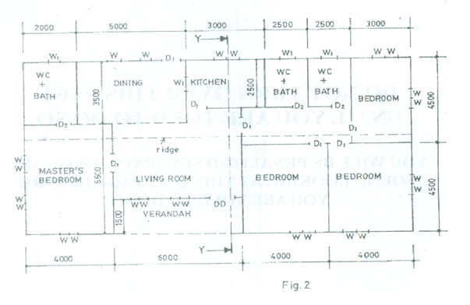
SPECIFICATIONS
All dimensions are given in millimetres.

FOUNDATION: 225 x 675 concrete strip foundation laid over 100 blinding at a depth of 900 below ground level.
FLOOR: 150 hardcore, 150 concrete slab, 25 mortar screed, finish floor level to ceiling 3150.
WALLS: All walls 225.
LINTELS: 225 X 225 reinforced concrete.
DOORS: All doors 2100 x 900 x 40 flush wooden in 100 x 50 timber frame except at verandah with glazed double door, 2100 x 1500 x 40 in aluminium frame.

WINDOWS: Sliding glass in aluminium frames, bath W.C. and store windows 600 x 600, others 900 x 1200.
BEAM: 225 x 225 reinforced concrete, 2400 above floor level.
COLUMN: 225 X 225 reinforced concrete.
ROOF: 25o double pitch with eaves 600 and corrugated asbestos sheets, timber rafter 1000 x 50 at 1000 centres, fascial board 25 x 250.
(Assume unspecified dimension)

a. Draw to a scale of 1:100 the:
i. Floor plan;
ii. Front Elevation;
b. Draw to a scale of 1:50, the sectional view on plane Y–Y.
Technical Drawing 3, WASSCE (PC 2ND), 2019, Q4

- Building Drawing Study the sketch plan of a three bedroom bungalow below and the given specifications to answer the questions that follow
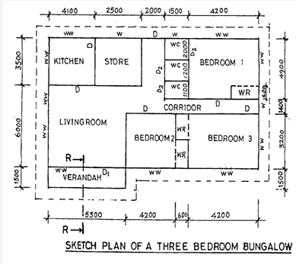
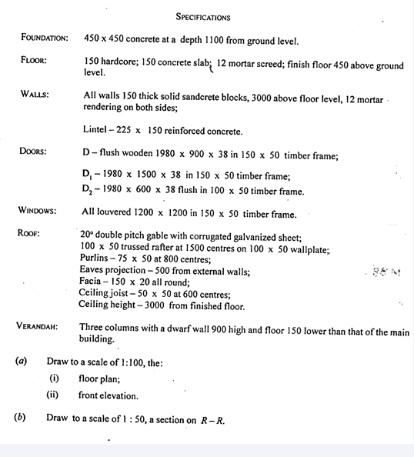

Technical Drawing Paper 2, Nov/Dec. 2011, section B, 1

